Student: Leonardo Oliveira

Class: CMSC 203

Professor:

STEP 1

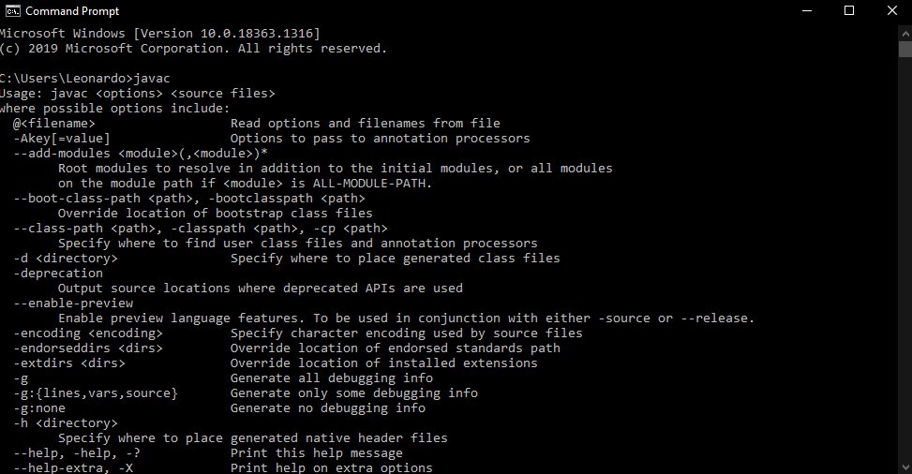

STEP 2

